FOCP C Programming Assignment
Module 2: Conditional Statements and Operators
Question 2: Smallest Even Multiple
Platform: LeetCode
Programming Language: C
Problem Link: https://leetcode.com/problems/smallest-even-multiple/
Problem Statement
Given a positive integer n, return the smallest positive integer that is a multiple of both 2 and n.
Examples
Example 1:
Input: n = 5
Output: 10
Explanation: The smallest multiple of both 5 and 2 is 10.
Example 2:
Input: n = 6
Output: 6
Explanation: The smallest multiple of both 6 and 2 is 6.
Constraints
- 1 <= n <= 150
Source Code
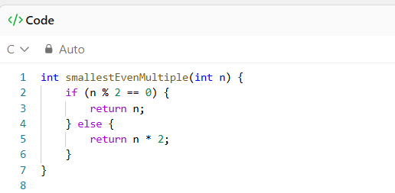

Output
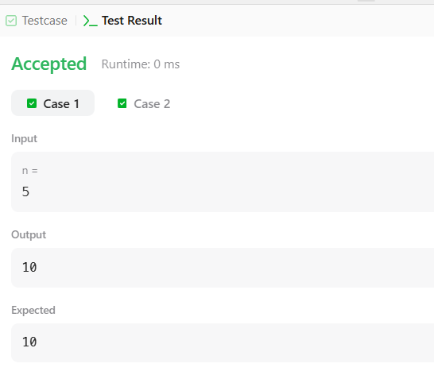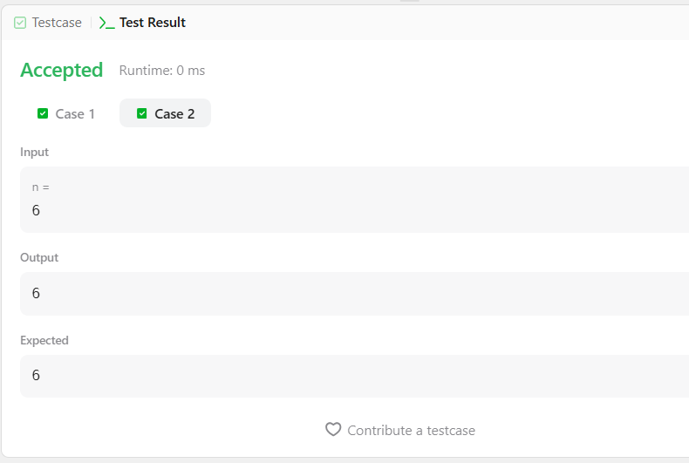
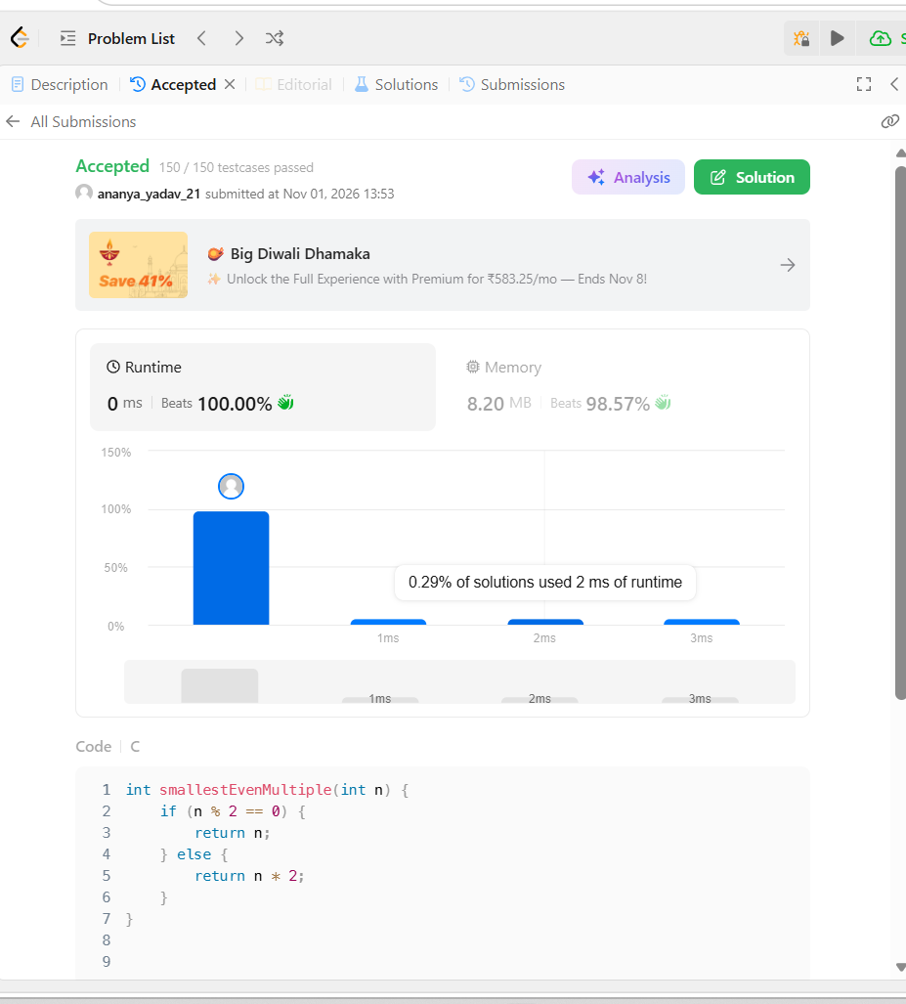

Result
The program was executed successfully, and all test cases were passed on LeetCode.

